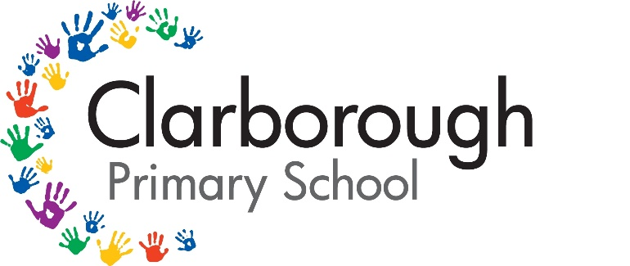

Behaviour Policy
Autumn Term 2025-2026

Review frequency: | Annually | Review date: | Autumn term 2026
Governing committee responsible: |  | Curriculum and Standards Committee
Governor approval: | Yes | Website: | Yes
Staff responsible: | Head Teacher | Date reviewed: | 03/11/2025

It is a primary aim of Clarborough Primary School that every member of the school community feels valued and respected, and that each person is treated fairly and well. We are a caring community, whose values are built on mutual trust and respect for all.

The school Behaviour Policy is therefore designed to support that way in which all members of the school can live and work together in a supportive way. It aims to promote an environment where everyone feels happy, safe and secure.

School Mission and ethos

At Clarborough Primary School, we have many minds but one mission: be the best you can be.

The importance of health, well-being, family and a love of learning permeate through our Golden Rule: We look after ourselves, others, our school and our planet.

Our staff and governors will work together to ensure that all those in our school community support our values: Clarborough values respect, resilience, learning. These values will ensure our pupils are successful learners, safe and nurtured, included and respected, effective contributors, active and healthy, confident citizens who are globally aware and the best they can be!

Clarborough Primary School’s primary aim of the behaviour policy is a means of promoting good relationships, so that people can work together with the common purpose of helping everyone to learn. This policy supports the school community in aiming to allow everyone to work together in an effective and considerate way.

We recognise and understand that:
- Behaviour is a form of communication of an unmet need, therefore, to change the behaviour we must respond to the unmet need.
- Children’s behaviour cannot be fully understood in isolation, without considering their individual influences.
- Relationship-based, restorative approaches offer an evidence-based effective practice to behaviour management systems.

At Clarborough Primary School, we encourage open discussions around differences between people, we actively challenge prejudice, and we celebrate diversity. We adopt a contextual safeguarding and trauma-informed approach to bullying and child-on-child abuse. Bullying will not be tolerated; we are committed to working with families and outside agencies where appropriate.

Roles and Responsibilities

Our behaviour policy supports our school vision, mission statement, ethos and ‘Golden Rule’. In the process of implementing this policy, we remind all staff, volunteers and governors that it is not acceptable to discuss children’s work or behaviour outside school. All staff, volunteers and governors should also ensure that they call children by their given or preferred name and should encourage all children to call staff by their title and family name. This policy should also be used in conjunction with the SEND policy.

All staff at our school are aware of the behaviour policy and approach and know the important role they have in promoting positive behaviour and preventing and tackling challenging behaviour.

The Head Teacher will ensure that the school environment encourages positive behaviour and that staff deal effectively with poor behaviour, and will monitor how staff implement this policy to ensure rewards and sanctions are applied consistently.

Staff are responsible for:
- Implementing the behaviour policy consistently
- Modelling positive behaviour
- Providing a personalised approach to the specific behavioural needs of particular pupils
- Recording behaviour incidents and meetings with parents on Arbor
- Use restorative practices to promote respect, responsibility and honesty
The senior leadership team will support staff in responding to behavioural incidents.

Parents are expected to:
- Support their child in adhering to the pupil code of conduct and signing the Home School Agreement
- Inform the school immediately of any changes in circumstance that may affect their child’s behaviour
- Discuss any behavioural concerns with the class teacher promptly

Pupils are expected to adhere to the following code of conduct:
- Behave in an orderly and self-controlled way
- Show respect to all members of staff and each other
- In class, make it possible for all pupils to learn
- Move quietly and walk around school
- Treat the school building and school property with respect
- Wear the correct uniform at all times
- Accept sanctions when given
- Refrain from behaving in a way that brings the school into disrepute, including when outside school

Key Principles

- Our system is designed on clarity and consistency. Expectations, rewards and consequences are set out clearly for pupils, staff and parents. We understand and acknowledge that for many, challenging behaviour is a manner of communicating core needs.
- Praise and sanctions are two distinct ways of modifying children's behaviour and must be treated separately - e.g. even a poorly behaved child will receive a class treat because individual challenging behaviour will have been dealt with through sanctions.
- Children should be praised every day.
- Consistency of language is important. We refer to the way children choose to behave and try to get them to consider better choices and we talk of the consequences of unacceptable behaviour, not the punishment.
- There is still room for discretion (a child maybe on an individualised plan) but consistency should be maintained where possible. If in doubt, refer to Head Teacher.

This policy is informed by practice developed within the school over previous years. It is guided by the principles highlighted in Nottinghamshire County Council (NCC) “Understanding behaviours in school” toolkit and has included input from staff members, BPBP behaviour partnership, representative from the governing body, parents, carers and pupils.

Rewards and Sanctions

Within the first week of returning to school each class will be reminded of the school’s mission, Golden Rule and ethos. Each class will also make their own collective rules which they will adhere to.

The emphasis of our Behaviour policy is ‘to concentrate on rewards for positive behaviour’. The school rewards good behaviour, as it believes that this will develop an ethos of kindness and co-operation. Both positive and negative behaviours are recorded on Arbor.

Clarborough Primary School encourages positive patterns of good behaviour by;
- The Home School Agreement sent to all parents, through their child’s planner, emphasises our concern for all pupils, their welfare and social development;
- Through the ethos of the school;
- Through the use of reinforcement of our Golden Rule;
- Through the teaching of PHSE in class and assemblies;
- Through the house system which rewards pupils’ efforts both academically and socially;
- The use of additional incentives such as certificates and special mentions in Star of the Week Assembly, participating in the Always, Always Tea party and whole school rewards
- The example set by staff in their attitude to and behaviour towards all members of the school community.

We praise and reward good behaviour in a variety of ways:
- With a pleasing look or smile;
- Verbal praise to the individual or written praise to the individual;
- Verbal praise for a Class or Group;
- Teachers use the ‘Proud Cloud’ for praising positive academic and social achievements (Consistent in every classroom)
- House points to be given to child or put on a child’s work e.g. being a good role model, helping younger children, improved behaviour at playtime etc
- Good behaviour or good work notes in planners and stickers to be given to the child to take home;
- Recognition of good work/behaviour by other Teachers or Classes
- Star of the Week certificates given out weekly in a recognition assembly linked to our Golden Rule
- Merit and Courtesy certificates each half term for children in each year group;
- A visit to the Head Teacher to show their good work;
- At the end of each half term, some children are invited to an ‘Always, Always’ tea party with the Head Teacher.
- Mid-day supervisor stickers or certificates for positive behaviour displayed at lunchtimes. They also give out half-termly Lunchtime Super Star awards.

Unacceptable Behaviour

Clarborough Primary School employs a number of sanctions to ensure a safe and positive learning environment for all. We employ each sanction appropriately to each individual situation. Where sanctions are deployed, parents must be notified and the behaviour must be logged on Arbor.

Low-intensity, high frequency behaviours cause Teachers and children most stress and interfere with effective teaching and learning in our classrooms. Children are reminded regularly of appropriate behaviours around school. Systems and procedures put in place to reduce risk and enable pupils and staff to engage in restorative practices which allows pupils recognise where they went wrong. (See Appendix 1 for restorative conversational dialogue example).

Hierarchy of sanctions

- If a child is disruptive in class, the teacher will remind the whole class (globally) of the school’s expectations – usually be referring to the schools Golden Rule; reinforcing what is right.
- If a child is disruptive in class, the teacher will remind the individual (locally) of the school’s expectations – usually be referring to the schools Golden Rule; reinforcing what is right.
- If undesirable behaviour continues, the child will be asked to change seats to another side of the classroom. After 10 minutes the child will be asked to engage in a restorative conversation with their class teacher, of how they can improve their behaviour or share any concerns they may have. This will be recorded on Arbor.
- If undesirable behaviour continues, the child will be removed from the classroom and sent to another class with their work to be completed. This is an internal exclusion. After 20 minutes the child will be asked to engage in a restorative conversation with their class teacher, of how they can improve their behaviour or share any concerns they may have. A warning card will be placed in their planner with explanation for parents. This will be recorded on Arbor and an internal notification will alert the Senior Leadership Team (SLT).
- If undesirable behaviour continues, the child will be removed and sent to a member of SLT. The child will be asked to engage in a restorative conversation with the SLT member of how they can improve their behaviour or share any concerns they may have and this discussion will be shared with their teacher and recorded on Arbor. A warning card will be placed in their planner with explanation and the class teacher will feedback to parents.
- If a child has three internal exclusions resulting in warning cards or removed to a member of SLT twice within a half term, they will be placed on a behaviour support plan (See Appendix 3). This plan will be created in conjunction with SLT, the class teacher and the child to ensure SMART targets are set, and these small steps to achieve, remain the focus throughout the plan. After every lesson, the class teacher will place red, amber, green faces with a short explanation of how the lesson went. The child will then have to report to SLT after every lesson for a short discussion based on the class teachers faces about how the lesson went. At the end of the first week the child’s parents will be called in to review the findings. From this the SMART targets can be reviewed too. This will be recorded on Arbor. The plan has been adapted from Bassetlaw Primary Behaviour Partnership (BPBP).
- The child will remain on the behaviour plan for two weeks. At the end of the second week, parents will be called in again to review their child’s behaviour plan. The plan will their either be deescalated and be removed or will be escalated to the SEND coordinator for additional support. Additional support comes in many forms; through the means of inhouse ELSA provision, or by completing an Early Help Assessment Form, or referring to the family SENDCO’s for further guidance, Think Children, BPBP Behaviour Partnership, the Educational Psychology Service, or other appropriate outside agencies. The communication between parents, staff and the child is vital here. This will be recorded on Arbor.
- Ensuring the safety of all staff and children is vital. If a child is not able to maintain a good standard of behaviour and show regard for the safety of themselves and others then it may be necessary to exclude them from certain activities, which may take place on or off the school premises, in or out of school time.

Exclusions (Fixed term and Permanent)

- At Clarborough Primary School, we do not exclude children commonly -nor as a primary response. This is a very serious repercussion of misbehaviour and one which is not a preferred course of action. Exclusions will only be used as a last resort.
- Only the Head Teacher (or Deputy Head) has the power to exclude a pupil from school. The Head may exclude a pupil for one or more fixed period, for up to 45 days in one school year. The Head may also exclude a pupil permanently. It is also possible for the Head to convert a fixed-term exclusion to a permeant exclusion, if the circumstances warrant this. The parents will be informed immediately. The Head will also make it clear that the parents are able to appeal against the decision of the governing body, if they wish to do so.
- Following any fixed-term exclusions, a reintegration meeting will take place with the child, their parents and the Head Teacher. The meeting will highlight ‘what went wrong’ and ‘how we can move forward’ to help mitigate any further incidences. The meeting will be minuted and recorded on Arbor.

Permanent Exclusion

A decision to exclude a pupil permanently should only be taken: ‘in response to serious or persistent breaches of the School’s Behaviour Policy; and where allowing the pupil to remain in school would seriously harm the education or welfare of the students or others in the school’ (DfE Suspension and permanent exclusion from maintained schools, academies and pupil referral units in England, including pupil movement. Guidance for maintained schools, academies, and pupil referral units in England [August 2024])
The Headteacher will make the judgement, in exceptional circumstances, where it is appropriate to permanently exclude a child.
Please find a list of examples whereby permanent exclusion may be appropriate, however it is important to note that this list is not exhaustive:
- Repeated failure to comply with a member of staff.
- Extreme physical or emotional abuse of staff or pupils.
- Serious sexual misconduct, including sexual harassment.
- False allegations made against staff.
- Breach of Health and Safety rules and regulations.
- Serious breach of school rules. In addition, the Governing Body also considers the following to be serious incidents resulting in the permanent exclusion of a student: Repeated or serious misuse of the school computers by hacking or other activities that compromise the integrity of the computer network.
- verbal abuse of staff.
- Persistent disruption and defiance that may or may not be directly linked to the sanctions in this policy.
- An accumulation of a high number of fixed term suspensions/behaviour points.
- Being in possession of a weapon and/or drugs.

Power to use reasonable force

Members of staff have the power to use reasonable force to prevent pupils committing an offence, injuring themselves or others, or damaging property, and to maintain good order and discipline in the classroom¹. At Clarborough School we ensure that we have members of staff who are trained in the use of Physical Intervention and should this ever be required the parents or carers of the child involved will be fully informed of the circumstances that led to this action being taken.
¹Behaviour and discipline in schools – January 2016 Department for Education

Monitoring

- The Head Teacher will monitor the effectiveness of this policy on a regular basis. They will also report to the governing body on the effectiveness and make changes or recommendations, where necessary.
- The schools keep a log of misbehaviour incidents on Arbor and where necessary in SEND files.
- The class teacher records incidents that occur both inside the building and on the playground/ field.
- The Head Teacher will keep a record of any pupil who is suspended for a fixed-term or who is permanently excluded.
- It is the responsibility of the governing body to monitor the rate of suspensions and exclusions, and to ensure that the school policy is administered fairly and consistently.

Appendix to Behaviour Policy
Appendix 1- Restorative practice example
Restorative practice
A restorative approach switches the focus to learning rather than conflict. It encourages pupils to think about how their behaviour has affected others. It helps children to develop respect, responsibility and honesty.

When pupils find themselves in conflict or upset we follow the five questions below and ask them:
- What happened?
- What were you feeling when it happened?
- What do you feel about it now?
- What needs to happen to put this right?
- What will you do differently next time?
When they are a little calmer we will also ask pupils the following three questions for them to reflect on:
- What would you think if this happened to you?
- What other choices could you have made?
- How could you make sure that this doesn’t happen again?
‘I’ statements

These can be used to convey the teacher’s needs and concerns or to tune in to the pupils needs and concerns:
- ‘I can see you’re upset, is it because...’ or ‘I feel concerned/worried/upset, that you are...’
- ‘I want you to put your hand up without calling out’ or ‘I want you to go back to your seat and work...’
- The following examples have been taken from the NCC document ‘Understanding behaviours in schools’ (2020)
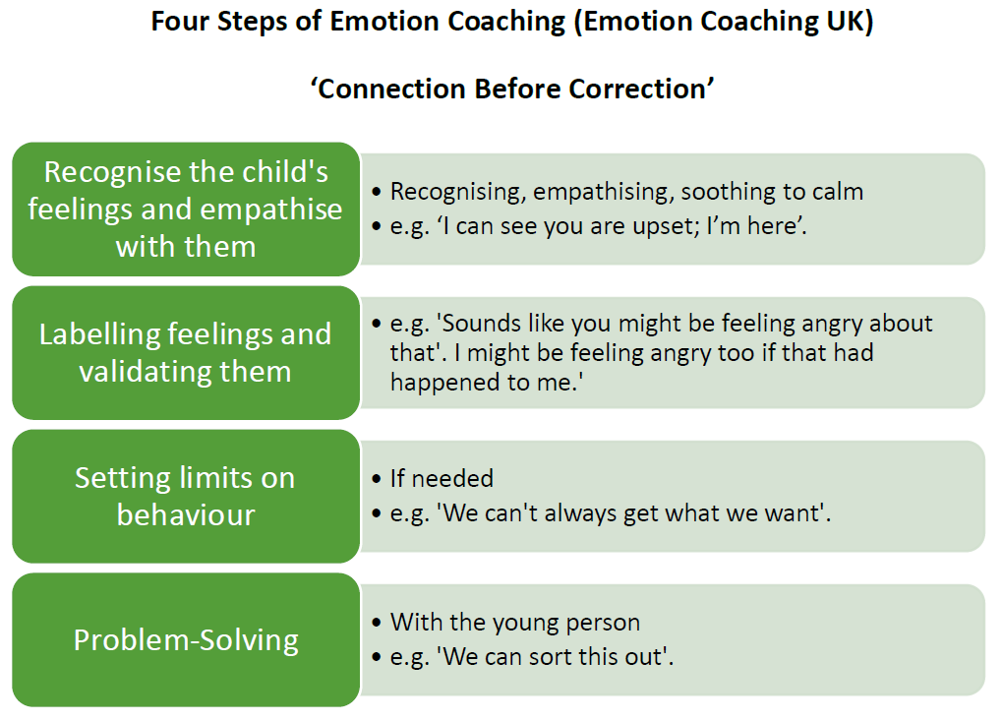

Appendix 2- Hierarchy of Sanctions
Hierarchy of Sanctions
Taken from Behaviour Policy

Positive reinforcement of what is right
Verbal warning to the child given globally

If undesirable behaviour continues, child to be verbally warned locally.



If undesirable behaviour continues, child will change seats to another side of the classroom. After 10 minutes they will engage in a restorative conversation with the Teacher. Record on Arbor.


If undesirable behaviour continues, the child will be sent to another classroom (Internal exclusion). After 20 minutes they will engage in a restorative conversation with the Teacher. Warning card in their planner with explanation for parents. Record on Arbor.

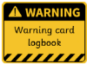
If undesirable behaviour continues, the child will be sent to SLT. When calm, they will engage in a restorative conversation with the SLT member. A warning card in their planner and the class teacher will feedback to parents. Record on Arbor.


If a child has three warning cards or is removed to SLT twice within a half term, parents will be invited in to talk to the Head Teacher and will follow the ‘My behaviour is being monitored’ behaviour plan. This will have SMART targets set out by the class teacher, pupil and Head Teacher with the aim of the child being able to achieve the small steps to improve their behavior. The class teacher will colour coded and write a short explanation and the pupil will have each lesson sign off by the Head Teacher. Record on Arbor.

After 1 week on behaviour plan – share week with parents and review
After week 2 on behaviour plan – Review with parents
Follow next steps as shown on plan


If behavior has not improved, work with SENDCO and parents at the next meeting to discuss next steps. Consider referral to Early Help or other appropriate agencies.


Appendix 3: My behaviour is being monitored by Clarborough Primary School’s Senior Leadership team.
Name w/b
My SMART target for this week is to:

 |  |  | break |  | lunch |  | break
Monday
Tuesday
Wednesday
Thursday
Friday

My teacher will colour code my chart after every lesson. I must then report to Mrs Cowell-Clark to discuss how I think my lesson went and they will sign my chart.
This week
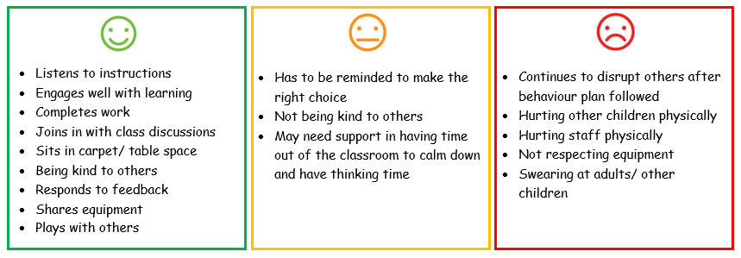

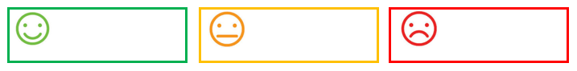


Week 1 monitoring visit held with parents
Behaviour has improved
No further action needed

Behaviour is still of concern
Arrange a meeting with SENCO

(Highlight as appropriate)
Week 2 monitoring visit held with parents and next steps discuss

Levels of Behaviour Management in school

*Tier 1 – Bassetlaw Behaviour Partnership agreed protocol
Level |  | Pupil Behaviour | Teacher Action | Extra Support
1  *T | These levels are managed by the class teacher  - eg MDS post its | Pupil respects the rights of others, is co-operative and self controlled | Positively reinforce behaviour – specific feedback e.g. encouragement, sharing success, responsibilities, red book, gold points. | Involve colleagues, parents and whole school in pupil achievement.
Pupil

2  I |  | Minor disruptions, talking, off task, poor concentration, low concentration levels. | Teacher seeks supportive solution with student, negotiating small steps to success. Use of loss of break times to complete work if appropriate, to reflect on disruption caused. Uses range of behaviour strategies | If necessary involve SENco or HT to define problem and assist in solution.
Pupil

3  E |  | Persistently infringes on the rights of others. Rude or disruptive behaviour. Continuing level 2 behaviour. | Teacher consults with colleagues and informs parents. Mohnitor with behaviour/incident logs and continue range of strategies | Involve support from HT.
Pupil

4  R  1 |  | Continually breaches the rights of others, verbal or physical assault, defiance or continued determination in behaviour. | Teacher consults with colleagues, support staff and parents. Behaviour / incident logs kept and reviewed with SMT. Modified playtime privileges, time out, daily behaviour report, agreed period of internal exclusion, withdrawal from school trip or other event | Involve HT, parent.
Pupil

5  Tier 2+ |  | Seriously violates the rights of others and shows no signs of wanting to improve e.g. abusive, poor effect on peers, uncooperative, verbal or physical assault. | Teacher refers the problems directly to SLT who will consider action in accordance with the appropriate policies, including the Restraint and Health and Safety policies. After discussion with pupil and parents internal or fixed term exclusion may be considered. | Involve HT, parent and other agencies.
Pupil

Example reasons for sanctions
Reasons why a child might be removed to another side of the classroom away from distractions. This will be classed as a minor offence (initial warnings may have been given):
- Disrupting learning
- Inappropriate verbal interruptions
- Pushing in a queue or making hurtful actions
- Not following expectations at play times and lunch
- Misusing school property
- Not responding to a direct request by an adult
- Displaying inappropriate facial gestures or body language
- Destroying the teaching or learning environment
- Using hurtful words or swearing
- Not following social distancing guidelines or hygiene, including hand washing and sanitising
- Not following expectations about ‘catch it, bin it, kill it’ when coughing or sneezing
- Coughing or spitting at or towards any other person

Reasons why a child might be removed to another classroom. This will be classed as a more serious offence. The child will be issued with a ‘Warning card’ and the Head Teacher will be informed.
- Low-intensity, high frequency behaviours that interfere with effective teaching and learning in our classrooms.
- Low-intensity, high frequency behaviours that interfere with children’s ability to enjoy their playtime
- Displaying violence including actions that cause pain, injury or fear to children or adults

Reasons why a child might be removed to a member of SLT. This will be classed a serious offence. The child will be issued with a ‘Warning card’.
- Displaying violence including actions that cause pain, injury or fear to children or adults
- Bullying
- Extreme abusive language, facial gestures or body language
- Racism
- Theft
- Threatening behaviour
- Vandalism of any kind
- Using the internet or mobile phones to harm or upset children or adults
- Any behaviour which is not in line with our four Golden Rules

If a child receives two visits to SLT within a half term, their parents will attended a meeting with the Head Teacher to discuss their behavior. A behaviour plan will be put in place and reviewed weekly (see behavior plan appendix). The safety and well-being of all our pupils is paramount and undesirable behaviours will not be tolerated.

How to record an incident on Arbor.
In the search bar type the child’s name,
Select- Behaviour tab, Incidents
Select- Add (green button on the right hand side)
Zone- where the incident occurred
Incident type- drop down menu to select
Details:
- Behaviour displayed,
- Consequence,
- Restorative conversation
Involvement:
- What happened before the incident occurred
Role – select from the drop-down menu
Guardian informed- yes/no drop down (should always be yes)

